|  |
| --- |
|  |
|  |
|  |
|  |

Investigate Mobile Apps

# Task 1: Investigation of Mobile Apps

The 2 apps I have chosen to investigate are the native to android app ‘Notes’ and a hybrid app that is on android, apple and the web browser called ‘WhatsApp’. I will investigate their purpose, target audience, functions and how the design has been influenced.

‘Notes’ is a free app on the google play store, it is a minimalistic notepad taking app that has only 2 functions, to create text documents and have them easily accessible to view at a single tap. The black and white colour scheme and default simplistic font creates a very ‘clean’ aesthetic.

In the top right there is a ‘+’ icon to create new notes or ‘memos’ and the whole screen is filled with buttons that have the name of the text documents on them and when clicked on they open the text document.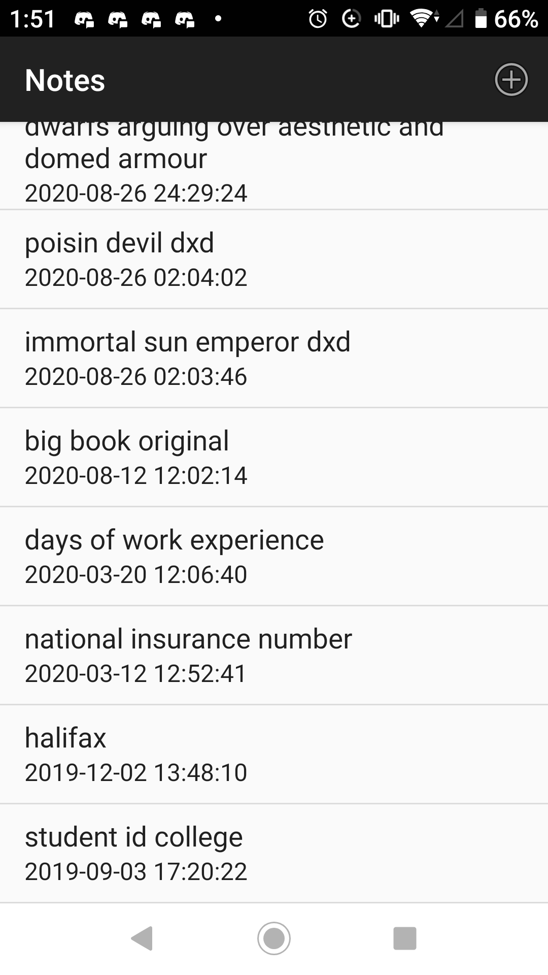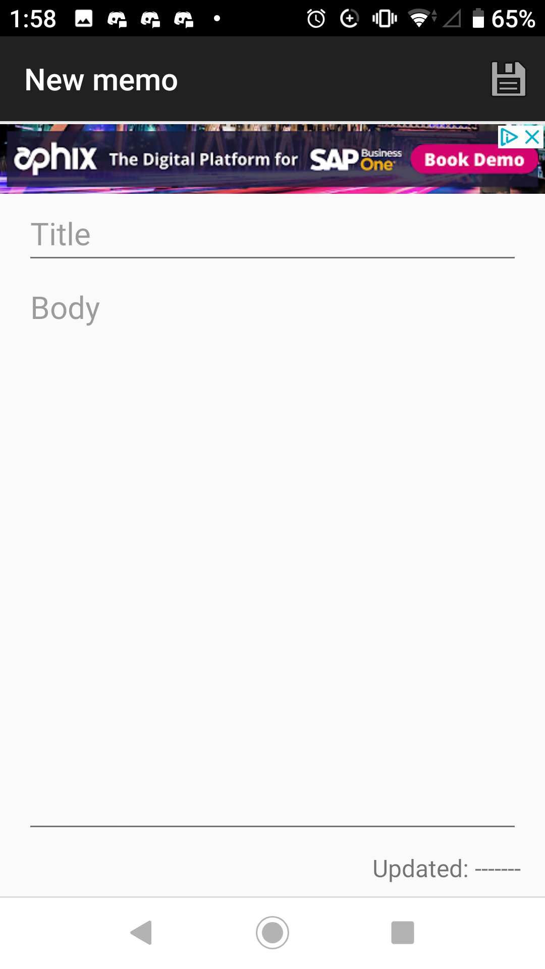

The buttons as you can see have the name of the document that they are attached to and the date that it was last edited.

The intended audience is anyone that needs to take notes, so it is very easy to use to reduce the learning curve.

The app makes use of the touch screen and on-screen keyboard to navigate between text files and edit them.

If I were to code this from scratch, I would use windows forms to create the buttons and ui, and use c# for the back end code that creates, accesses and edits text documents.

I believe that this app could be improved by making it a widget.

WhatsApp is a social media app for messages and calls, you can send all kinds of media to someone directly or in a group chat with multiple people involved as recipients.

This is not a native app, it is hybrid as it is on virtually all platforms, android, iOS, windows and the web.

There is a wide range of intended audience that this app targets as it is primarily used for communication between people. According to Experian marketing services ‘71% of users are in the age bracket of 18-44' this is the age of most users of WhatsApp and it caters mainly to their needs rather than children’s, with its lack of games.

However, it is a superb form of communication only needing an internet connection, whether that be data or wi-fi, to send messages, media, links or calls.

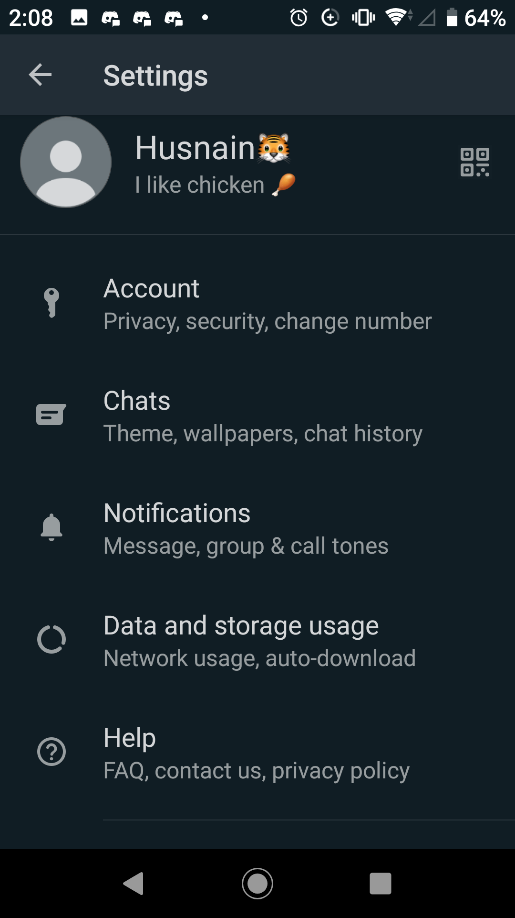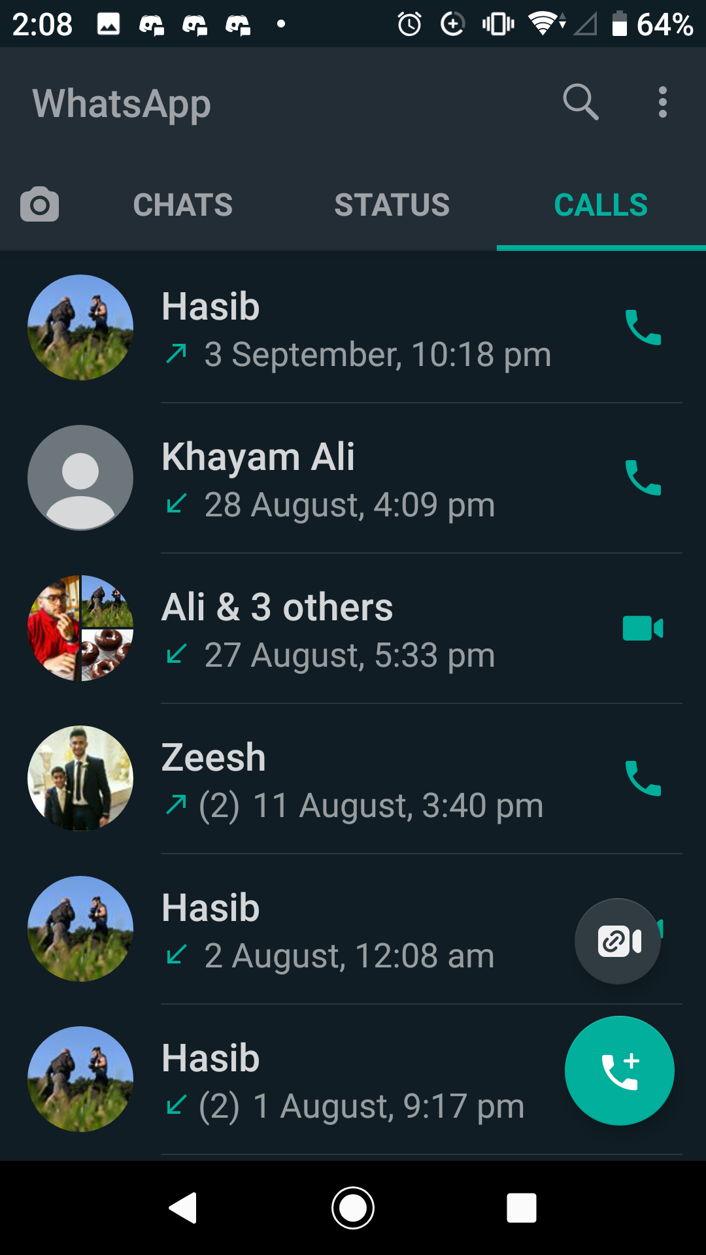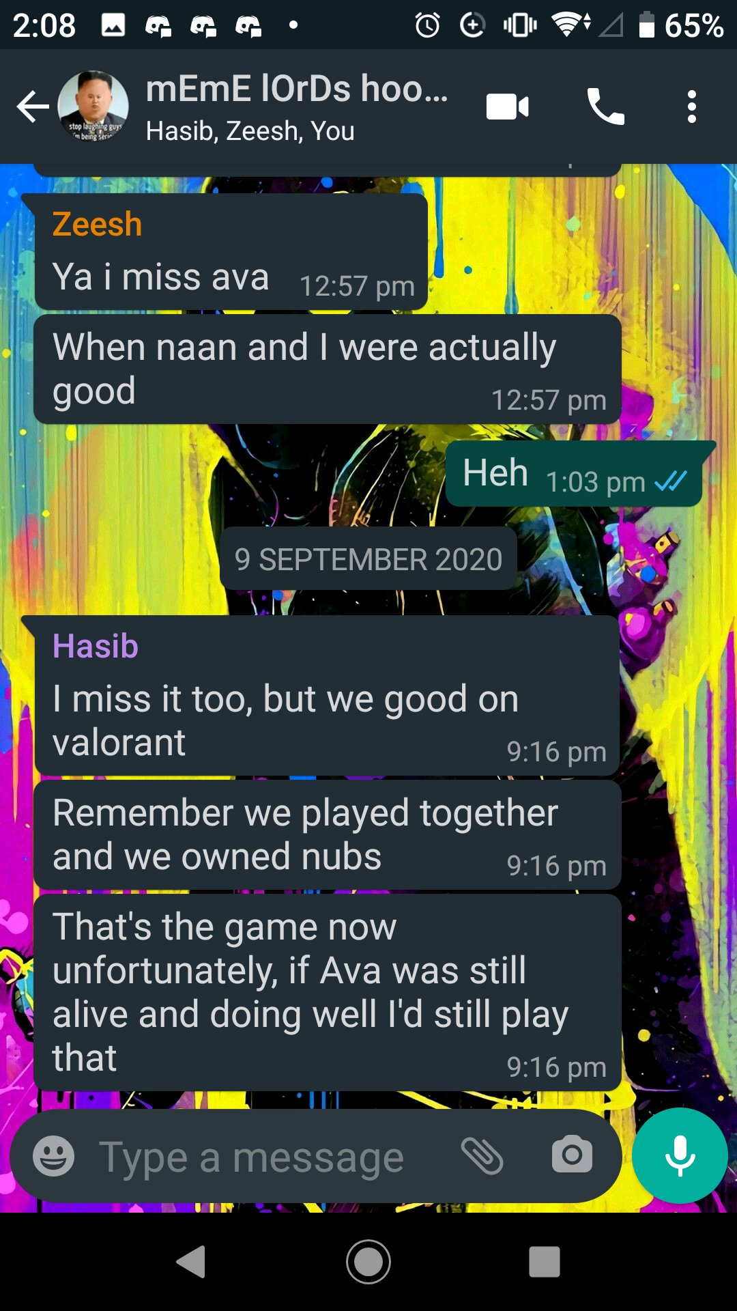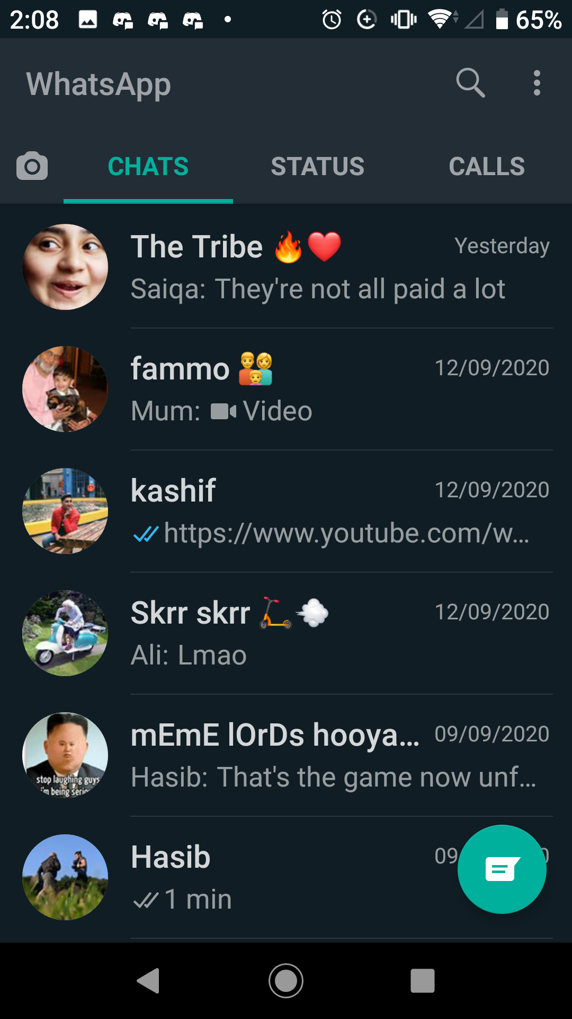

WhatsApp web

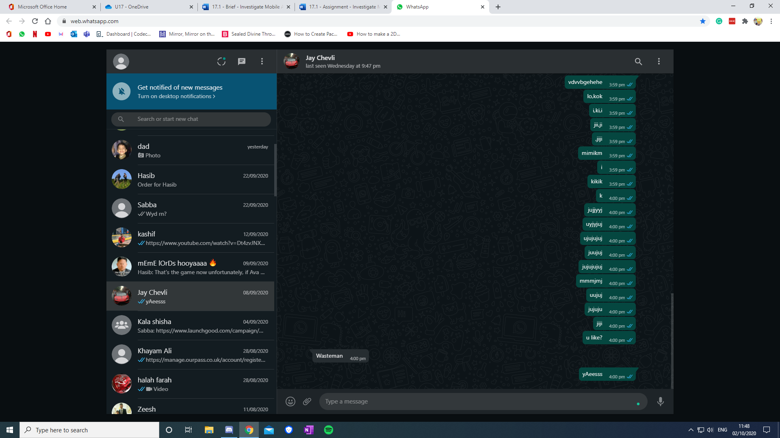

This is the web version of WhatsApp.

# Task 2: Analyse and Evaluate a Range of Mobile Apps

The 2 multi-platform apps I have chosen to investigate are ‘Instagram’ and ‘YouTube’.

# Instagram is a free media sharing app that is available on android, iOS and the web. It is mainly visual with the only text being in the captions of your posts (not including private messaging). It allows images in a 1:1 square ratio and videos up to 1 minute long.

The intended audience is the younger generation as majority of the users are in between the ages of 18 and 29.

According to Piper Jaffray's 2019 Taking Stock with Teens consumer insights survey, 85% of teens say Instagram is their preferred social network (followed shortly by Snapchat). - https://blog.hootsuite.com/instagram-demographics/

This shows that it is very popular with the younger generation both as a way to communicate to their friends and family and keep up to date with occurrences and news around the world, down to silly things like watching cat videos.

The mobile version of Instagram has functions such as liking someone’s posts and saving them to an archive for later viewing, commenting on posts or sharing them to others via dm’s so they can see them, a private messaging function called DM’s for 1 on 1 chats or group chats with multiple participants, 24-hour stories which are short videos or images that can only be seen for an entire day before disappearing, searching for other users by their usernames to find their page and their posts, following users to get their posts on your home page or blocking them so that they cannot interact with you or see your posts.

The mobile app uses the touch screen to navigate between the different features and screens. It uses camera to take pictures and the microphone for sound in videos. It uses the speakers for outputting sounds.

The main difference between the web and phone versions of this are the fact that on the web version you cannot upload and take images via the camera (or webcam). The desktop version also allows you to view peoples posts and profiles without logging in as long as they have a public profile (private profiles require you to follow them to see their posts and stories) while the mobile app doesn’t, it needs you to log into an account to use the app. Desktops also don’t have autocorrect like mobile does.

Some positive points of Instagram are the high privacy it gives and as it is a highly visual platform, primarily dealing with photos this is very good as you may not want everyone to see some of your private photos of you or your family.

Another pro of the app is that it is very good for people who like to travel as t has a geo tagging feature where you can point out where on the map a photo was taken and so people can see photos of famous places and landmarks.

A negative point of Instagram is the fact that you must follow people to see their posts if their profile is on private, this however, could be seen as a good point as it increases security.

Another negative point is that it can be a detriment to your mental health as people may obsess over the number of likes that they get, and they may get mean comments on their posts that hurt their feelings.

A downside to this app is the overwhelming amount of advertisements that plague the platform and interrupt your viewing experience.

Some more problems are the inadequate tech support and the fact that privacy settings cannot be applied to individual posts and only to your profile as a whole so they apply to all of your posts.

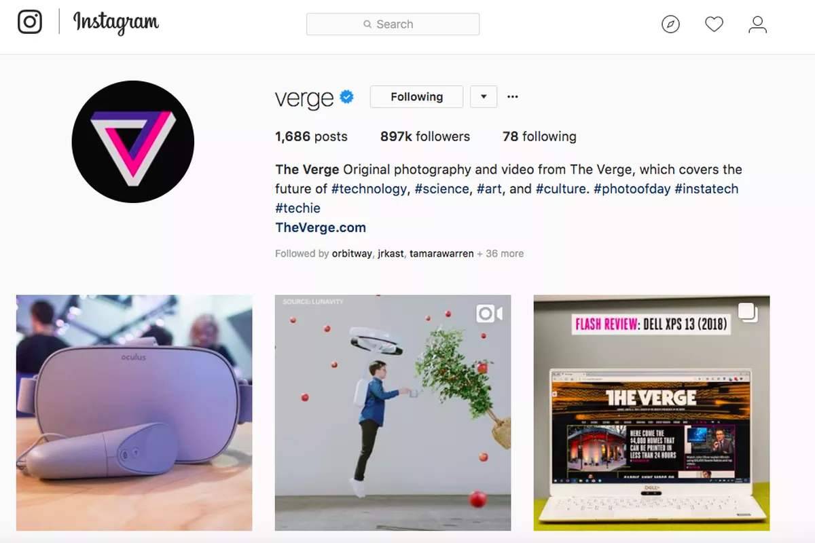

# Overall Instagram is a very good app that makes use of its features very well and does its purpose. As it is primarily a mobile app the website takes after the app for most of its design as well as taking a 16:9 resolution with blank bars on the sides of the screen.

# YouTube is a free video sharing and livestreaming platform that can hold up to 24-hour videos of all qualities and ratios, it is available on all platforms including but not limited to android, iOS, windows phone, web, Xbox, PlayStation and smart tv.

The target audience is any and all people as there is content available for people of all ages, some videos that show mature content are age restricted to accounts that show you are 10 or over, there is also another app called YouTube kids that only shows child friendly content with no depicted gore and swears.

Now that YouTube is a decade old it has quite a broad reach over a multitude of different people and is used by all kinds of people unrestricted to race or age. However, millennials do watch more YouTube than the older generation.

As with all social media there is still a chance that you may see something unsatisfactory that offends you or you do not deem appropriate for viewing, in which case you can flag the video and file a report.

Some of the functions that YouTube has are uploading videos/livestreams, viewing videos/livestreams, searching for videos, playlists and channels, subscribing and following other users so that you are notified when they upload any videos, liking/commenting on/sharing videos with others via other social media.

A mobile exclusive function is the ability to download videos onto your device for offline use, this helps with viewing videos on the go without an internet connection. It uses the touch screen to navigate it and the on-screen keyboard to type as phones do not have an attached keyboard and mouse. The mobile app also has the exclusive feature of push notifications to notify subscribers, but most people opt out of these by turning them off.

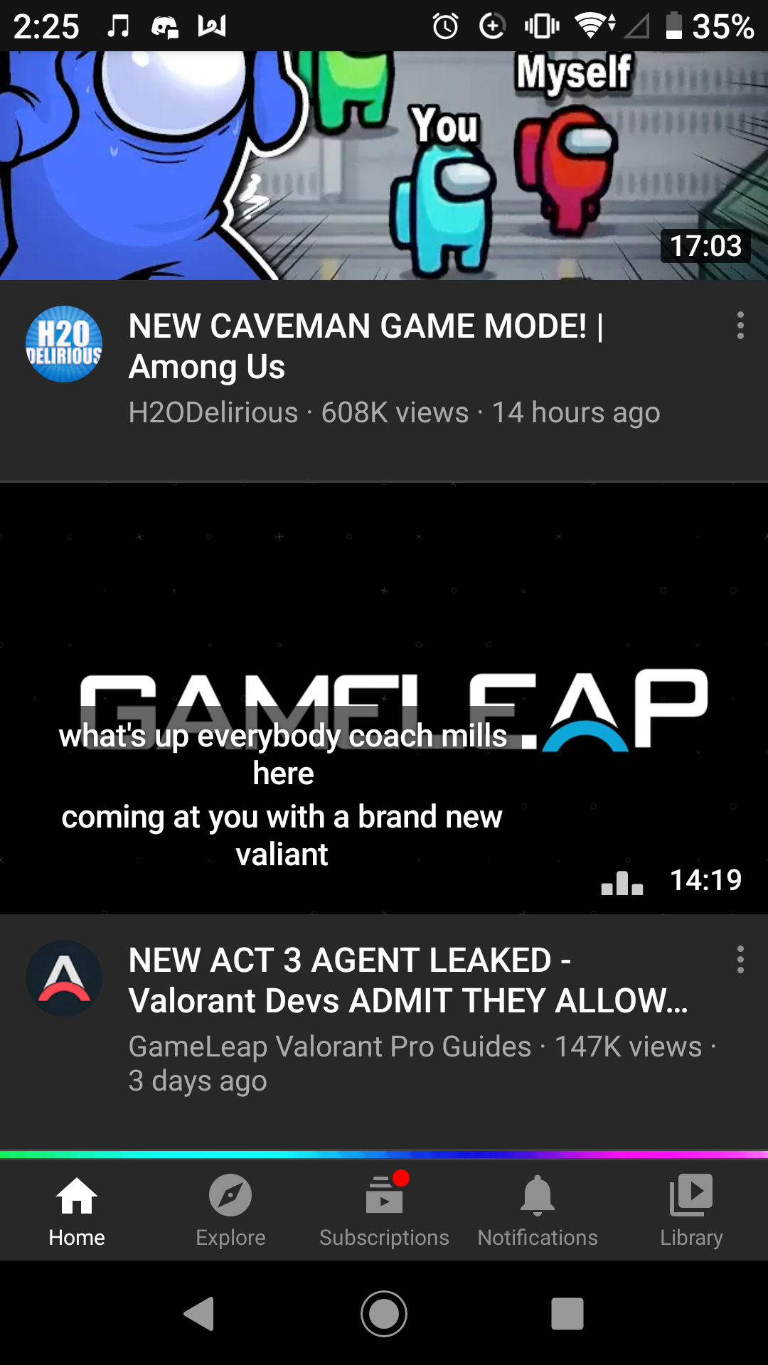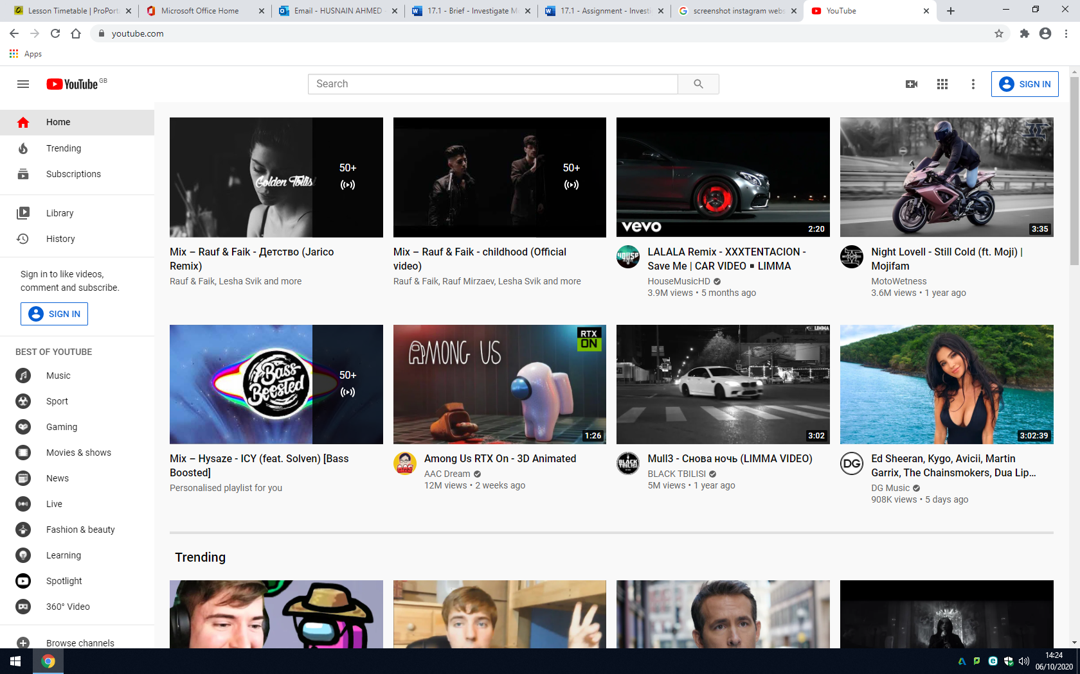

The design layout differs for both mobile and pc versions of the app. The mobile version is in portrait whilst the website is landscape due to the orientation of most smart phones being different to the landscape monitors of computers and laptops.

The website has a navigation bar on the left side whilst the mobile app has it on another screen that can be navigated from the icons at the bottom.

The design layout differs for both mobile and pc versions of the app. The mobile version is in portrait whilst the website is landscape due to the orientation of most smart phones being different to the landscape monitors of computers and laptops.

The website has a navigation bar on the left side whilst the mobile app has it on another screen that can be navigated from the icons at the bottom.

Both versions of YouTube have a preview of the videos, but they are accessed in different ways. On pc they are accessed by hovering over the thumbnail for a video with the mouse cursor and on mobile they are activated by having a video in the middle of your screen for a few seconds (shown in the screenshot).

A pro of YouTube is how easy it is to use for viewing and for uploading videos so that people can enjoy them, becoming a content creator is a dream of many and being paid for it as a full-time job is even more so.

Another pro is the marketing benefits you gain from having adverts on your videos, these allow you to be paid for the amount of views you get and if people click on the ads instead of skipping. Some ads can be skipped in 5 seconds and others are unskippable for a full 30 seconds.

Another pro is that it is the biggest hub of videos of all kinds of content including but not limited to education, entertainment, music, gaming and more.

A negative point of YouTube is that there is a lack of privacy, once a video is out there it can be seen by all. You can put videos on private but then no one at all can view them, the main point of uploading videos is for others to find and watch them. If you only want certain people to watch videos you can have the on unlisted and send them the link so that they can only watch it through the link.

Another con is the inappropriate content you could find, from things like videos of hate speech that you don’t want to see or downright rude comments on videos, YouTube’s algorithm for searching is not very good and you can find content that you don’t want to by accident, also although there is a feature for content creators to disable the comment section there is no limit on what users can comment on videos that have it enabled so unless the creator reads every single comment and removes the ones that are offensive in some way or other the comments remain unfiltered.

Another con is the copyright infringement that can take down your videos if you use other people's content, be it music or photos. YouTube claims to take this seriously but there is still many channels out there that post plagiarised content without feeling the repercussions of it.

YouTube and Instagram are both visual based social media apps that are more focused on media than text, YouTube focuses on videos and Instagram focuses on both videos and photos but more so on photos.